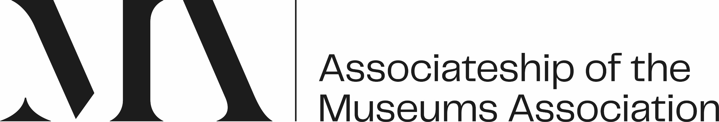

Fast Track Associateship of Museums Association (AMA):
Expression of Interest (EOI)

Name
Membership Number
Membership Type
Role Title

The AMA is your opportunity to take ownership of your professional development and career. It helps you think about the future, your interests, and aspirations.

Every AMA journey is different, but all journeys are supported by the same development framework – clearly communicated competencies, mentoring, workshops, support groups and resources.

Our new Fast-track AMA programme supports the development and recognition of those individuals who have worked with or in the sector for more than 5 years, and on that basis will have developed their competence expertise over this time.

A competency is skills, knowledge, and behaviour that when combined result in good role performance. We have six competencies, supported by competency statements to provide additional detail and focus, at four distinct levels:
- Developing self and others
- Empowering collections
- Engaging audiences and communities
- Leading and change making
- Managing people, money, and organisations
- Sustaining relationships and partnerships

This Expression of Interest helps you:
- begin your reflective journey
- share your motivations for undertaking the AMA over a 12-month period
- familiarise yourself with the Competency Framework, on which you are assessed
- reflect on your strengths and development needs

Steps to complete - Expression of Interest

The first step in your Fast Track AMA journey is to reflect on your drivers for participation.
Reflect on the six questions below around your motivations and hopes for the Fast track AMA.

Why are you interested in starting the AMA? 200 words max.
What are you hoping to gain from this experience? 200 words max.
Why do you feel the Fast track AMA is a good fit for you? 200 words max.

The Fast track AMA programme lasts for 12-months, with the expectation you will participate in a professional review, the end-point assessment, within that 12-month period.
Please reflect on the competencies. Which competency reflects the majority of your experience to date? 200 words max.
Which competency do you feel you need to develop most over the course of the AMA and why? 200 words max.
How will you balance your time and activities to achieve your AMA in 12-months? 200 words max.
What support do you feel you may need as part of this AMA journey? 200 words max.

Please return this section, with a copy of your CV to tamsin@museumsassociation.org

