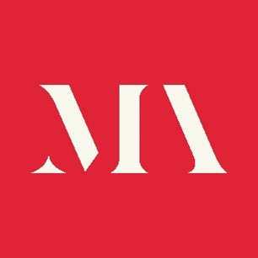

Application Form

Role applied for: Nations Committee (please state which country)

Personal Details

Name

Address

Email address

Contact Telephone

Individual membership number

Professional biography
Please enter a brief professional biography below (no more than 100 words).

Personal Statement
Please enter your personal statement below (maximum 300 words) outlining the values, qualities and experience you would bring to the nations committee.

Are you related to any member of the staff or board of the Museums Association?

Declaration
The information I have given in this application form is correct.
Signature Date

Data privacy
We will treat all personal information in line with current data protection legislation and our data protection policy.

Please return the completed form to Alice Chalk Alice@museumsassociation.org by midnight 30 September 2025

